Institute of Infrastructure, Technology, Research And Management

Maninagar(East), Khokhra, Ahmedabad - 380008.

Phone: 079-67775488 / 99. E-mail[:office@iitram.ac.in](mailto:office@iitram.ac.in)

Form Fee: Nil

**Hostel Admission Form**

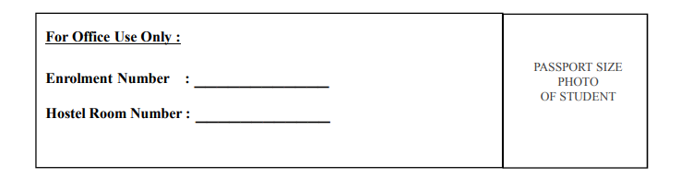

To, Registrar IITRAM

Sir,

I wish to apply for accommodation in Hostel managed by IITRAM from the academic year 2024-25.

I hereby agree that I have read and will abide by the Rules and Regulations of the hostel in force from time to time. I furnish the following particulars:

**PERSONAL DATA:**

Full Name : (Surname First)

Permanent Residential Address :

E-mail : Contact No. (M) :

(R) :

Date of Birth : (DD-MM-YYYY)

I declare that the information given above is true to the best of my knowledge. I agree that if any infor- mation furnished above found incorrect my admission is liable to be cancelled.

Date: **Signature of Candidate**

**FAMILY BACKGROUND:**

Full name of the Parent/Guardian:

|  |  |
| --- | --- |
| Relationship | : |
| Occupation | : |
| Designation | : |
| Office Address | : |
| E-mail | : |
| Tel. No. (with STD Code) | : |

**NEAREST LOCAL GUARDIAN:**

Name and address of contact persons who should be contacted (in case of emergency)

1. Name :

Address :

:

E-mail : _

Tel. No. (Mob / Res) :

1. Name :

Address :

:

E-mail : _

Tel. No. (Mob / Res) :

I request you to admit my ward Mr. / Ms.

To the IITRAM Hostel. I give an undertaking that he / she has read and will observe all Rules & Regulation of the Hostel.

Yours faithfully

Date: Signature of the Parent / Local Guardian